Smart LED Strips

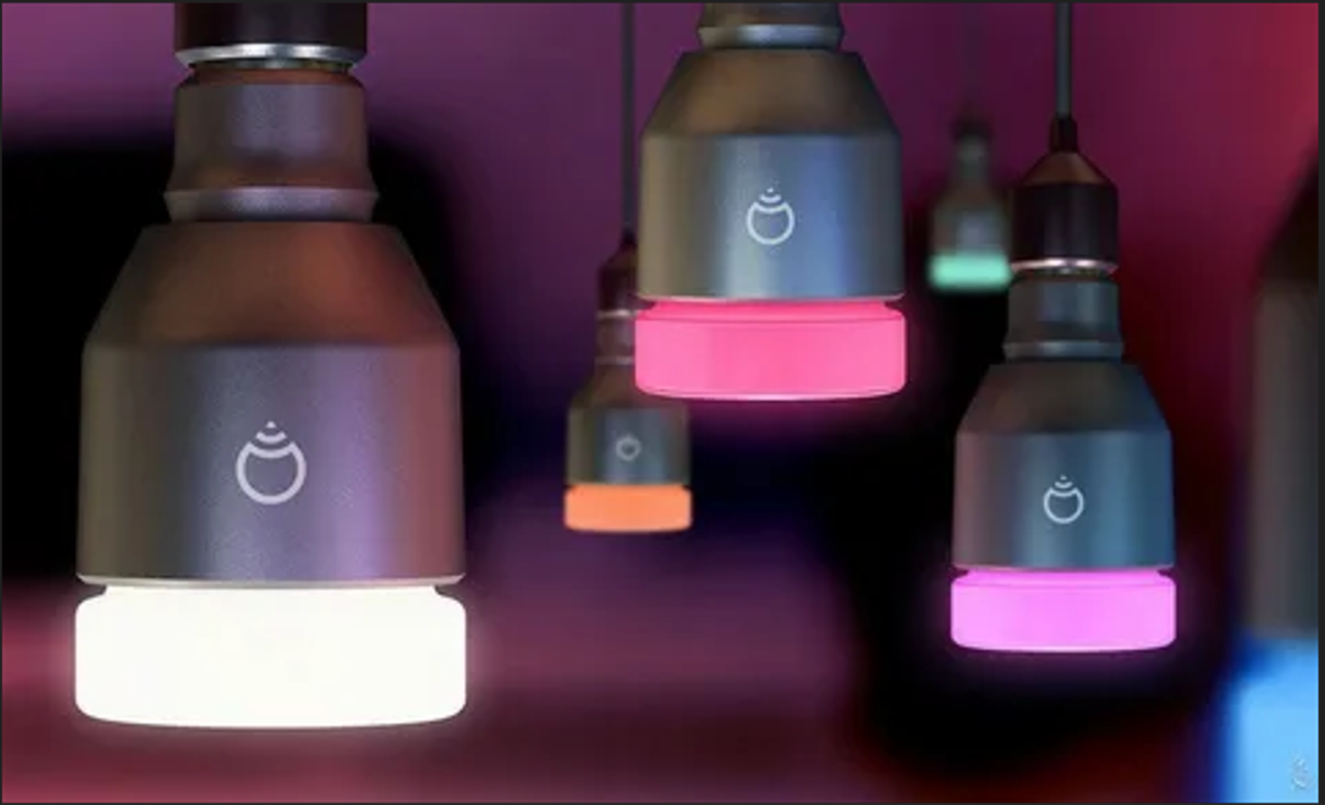

#### ****Description:****

**Smart LED Strips** are flexible, energy-efficient lighting solutions that allow you to customize your home lighting with 16 million colors. These strips are perfect for creating the perfect ambiance for any occasion, from cozy movie nights to vibrant parties. With features like dimming, color changing, and scheduling, Smart LED Strips offer a convenient and customizable lighting experience.

* **Technology:** Wi-Fi, Bluetooth, or Zigbee (depending on the model).
* **Compatibility:** Works with iOS and Android devices.
* **Length:** 16.4 feet (5 meters).
* **Color Options:** 16 million colors + adjustable white light (2200K-6500K).
* **Dimmable:** Yes.
* **Lifespan:** 50,000 hours.
* **Energy Efficiency:** Energy Star certified.
* **Control Options:** Mobile app, voice control (Alexa, Google Assistant, Apple HomeKit).

#### ****Key Features:****

* **Customizable Lighting:** Choose from 16 million colors and adjust brightness to create the perfect ambiance.
* **Voice Control:** Compatible with Alexa, Google Assistant, and Apple HomeKit for hands-free control.
* **Energy-Efficient:** Uses up to 85% less energy than traditional incandescent bulbs.
* **Scheduling and Automation:** Set schedules, timers, and routines for automated lighting control.
* **Group Control:** Control multiple strips simultaneously for synchronized lighting.
* **Music Sync:** Some models offer music sync features that change colors with the beat of your music.
* **Cuttable:** Can be cut to fit specific lengths (at designated cut points).

#### ****Pricing:****

* **Single Strip:** $39.99
* **2-Pack:** 69.99(69.99(35.00 per strip)
* **4-Pack:** 129.99(129.99(32.50 per strip)

#### ****Where to Use:****

* **Living Rooms:** Create a cozy or vibrant atmosphere with customizable colors.
* **Bedrooms:** Set the perfect lighting for relaxation or wake-up routines.
* **Kitchens:** Brighten up workspaces with adjustable white light.
* **Home Offices:** Enhance productivity with focused lighting.
* **Parties:** Set the mood with dynamic color-changing effects.
* **TV Backlighting:** Enhance your viewing experience with ambient lighting.

### ****Customer Reviews:****

* ⭐⭐⭐⭐⭐ "These Smart LED Strips are amazing! They were super easy to set up, and I love controlling them with my phone. The colors are so vibrant!" – Sarah L.
* ⭐⭐⭐⭐ "Great value for the price. The strips are bright, and the app is easy to use. Highly recommend for anyone looking to upgrade their smart home lighting." – James T.
* ⭐⭐⭐⭐⭐ "I love how energy-efficient these strips are. The scheduling feature is a game-changer for my daily routine." – Emily R.

### ****How to Order:****

1. Visit our website: [www.brightworldlighting.com](http://www.brightworldlighting.com/)
2. Select your preferred pack size (Single, 2-Pack, or 4-Pack).
3. Add to cart and proceed to checkout.
4. Enjoy free shipping on all orders over $50!

### ****Warranty and Support:****

* **Warranty:** 2-year limited warranty covering manufacturing defects.
* **Customer Support:** Contact us at [support@brightworldlighting.com](mailto:support@brightworldlighting.com) or call +1-800-123-4567 for assistance.

### ****Visual Representation:****

Include high-quality images of the Smart LED Strips in different settings (e.g., living room, bedroom) to showcase their versatility and design.